**Step 1: Create a sample recipe file of apache2 cookbook**

# vim /home/ubuntu/chef-repo/cookbooks/apache2/recipes/default.rb

service 'apache2' do

action [ :enable, :restart ]

end

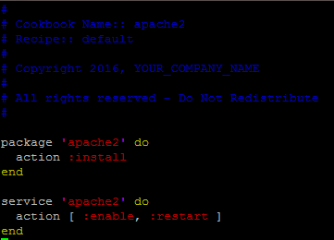

Run

Chef-client on your ubuntu node